A health impact assessment of changes in NDVI on all-cause mortality across 1,041 global cities

Greta K. Martin¹, Jennifer D. Stowell², Patrick L. Kinney², Susan C. Anenberg¹

¹The George Washington University Milken Institute of Public Health, Washington, DC
²Boston University School of Public Health, Boston, MA

SUPPLEMENTAL MATERIAL

Contents of this file

List S1
Figures S1-S9
Table S1-S2 (Table S3 uploaded separately)

List S1. Countries not represented in analysis.

- Andorra
- Antigua and Barbuda
- Eswatini (former Swaziland)
- Dominica
- Grenada
- Holy See
- Kiribati
- Liechtenstein
- Marshall Islands
- Micronesia (Federated States of)
- Nauru
- Palau
- Saint Kitts and Nevis
- Saint Lucia
- Saint Vincent and the Grenadines
- Samoa
- San Marino
- Seychelles
- State of Palestine
- Tonga
- Tuvalu
- Vanuatu

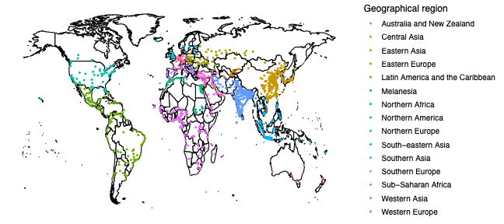
Figure S1. Map of the 1,041 global cities by United Nations Statistical Division sub-regional classifications.
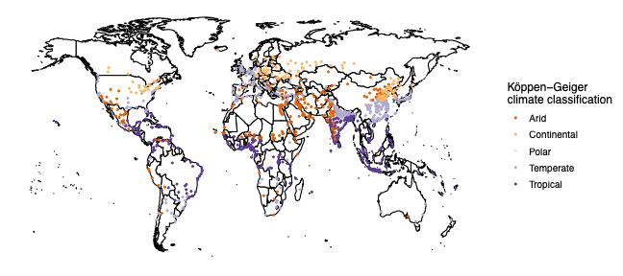
Figure S2. Map of the 1,041 global cities by Köppen-Geiger climate classification.

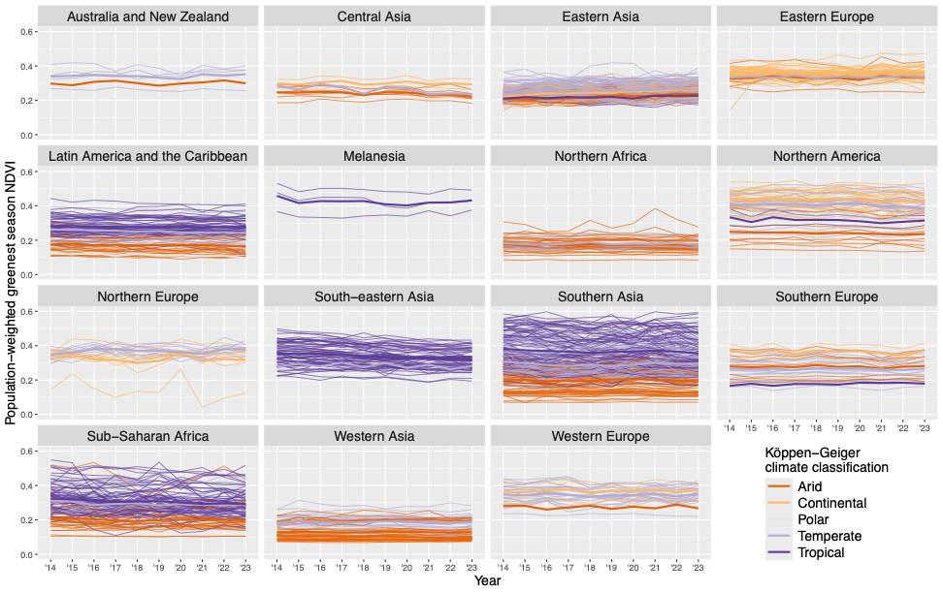
Figure S3. Population-weighted greenest season average Normalized Difference Vegetation Index (NDVI) from 2014-2023 by geographic region. Each thin line represents an individual city within the geographic region, while each thick line shows the average NDVI for all cities in that region, colored by climate classification.
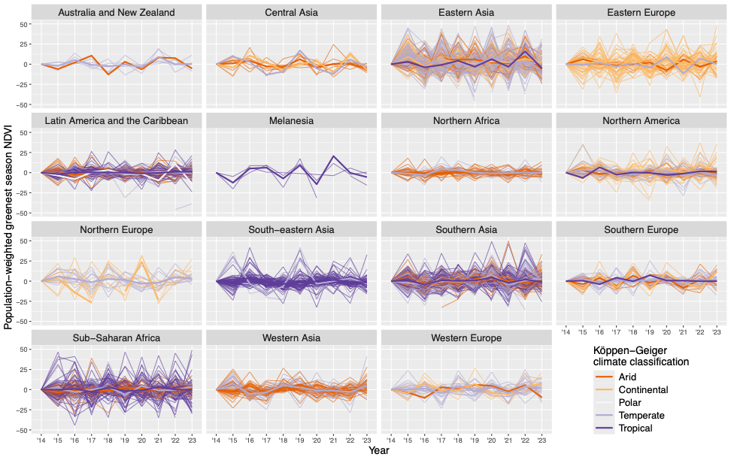
Figure S4. Percent change from previous year in city average annual population-weighted greenest season Normalized Difference Vegetation Index (NDVI) from 2014-2023 by geographic region. Thin lines represent individual cities, and thick lines show the average NDVI percent change for all cities, colored by climate classification.
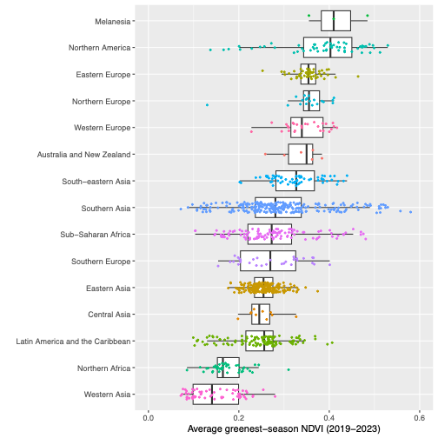
Figure S5. Average 2019-2023 city-level population-weighted greenest season Normalized Difference Vegetation Index (NDVI), by geographic region.
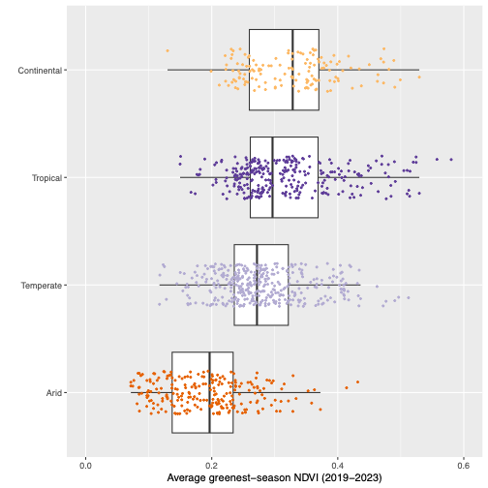
Figure S6. Average 2019-2023 city-level population-weighted greenest season Normalized Difference Vegetation Index, by Köppen-Geiger climate classification. One city classified as Polar was dropped (El Alto, Bolivia, 0.107).

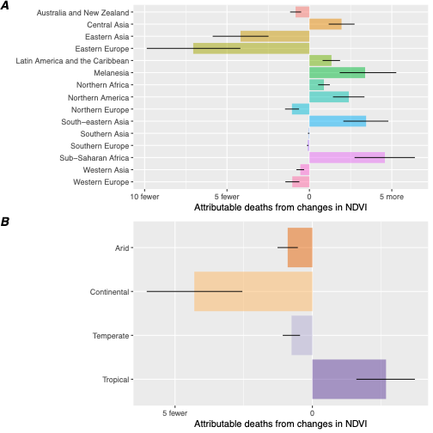

Figure S7. Total associated changes in deaths per 100,000 from changes in average population-weighted peak season Normalized Difference Vegetation Index from 2014-2018 to 2019-2023 to the 2020 population, by region (panel A) and climate classification (panel B). One city classified as “Polar” was dropped from panel B (El Alto, Bolivia, 4.78 (95% CI: 3.11, 8.51) more deaths per 100,000 population). The black bars represent the 95% confidence intervals, considering measured error in the mortality and risk ratio estimates.

Table S1. Total change in deaths in absolute and population-standardized terms from changes in in average population-weighted peak season Normalized Difference Vegetation Index from 2014-2018 to 2019-2023 in the 2020 population, by region.
Region | Population (2020) | Change in mortality | 95% CI absolute |  |  | Change in mortality (per 100,000) | 95% CI  (per 100,000)
Region | Population (2020) | Change in mortality | lb | ub |  | Change in mortality (per 100,000) | lb | ub
Australia and New Zealand | 12345979 | -103 | -145 |  | -61 | -0.84 | -1.17 | -0.50
Central Asia | 12976956 | 253 | 151 |  | 356 | 1.95 | 1.17 | 2.74
Eastern Asia | 492132074 | -20593 | -28866 |  | -12214 | -4.18 | -5.87 | -2.48
Eastern Europe | 64369399 | -4540 | -6351 |  | -2697 | -7.05 | -9.87 | -4.19
Latin America and the Caribbean | 229040750 | 3066 | 1832 |  | 4271 | 1.34 | 0.80 | 1.86
Melanesia | 652835 | 22 | 12 |  | 34 | 3.39 | 1.84 | 5.27
Northern Africa | 78336973 | 690 | 411 |  | 969 | 0.88 | 0.53 | 1.24
Northern America | 140358784 | 3362 | 2010 |  | 4683 | 2.40 | 1.43 | 3.34
Northern Europe | 28851881 | -305 | -427 |  | -181 | -1.06 | -1.48 | -0.63
South-eastern Asia | 202014534 | 6951 | 4153 |  | 9679 | 3.44 | 2.06 | 4.79
Southern Asia | 467009884 | -194 | -441 |  | -1 | -0.04 | -0.09 | 0.00
Southern Europe | 38150645 | -41 | -58 |  | -24 | -0.11 | -0.15 | -0.06
Sub-Saharan Africa | 199295623 | 9135 | 5461 |  | 12759 | 4.58 | 2.74 | 6.40
Western Asia | 111143374 | -606 | -873 |  | -354 | -0.55 | -0.79 | -0.32
Western Europe | 41372890 | -430 | -604 |  | -254 | -1.04 | -1.46 | -0.61

Table S2. Total change in deaths in absolute and population-standardized terms from changes in in average population-weighted peak season Normalized Difference Vegetation Index from 2014-2018 to 2019-2023 in the 2020 population, by climate classification.

Climate Classification | Population (2020) | Change in mortality | 95% CI absolute |  |  | Change in mortality (per 100,000) | 95% CI  (per 100,000)
Climate Classification | Population (2020) | Change in mortality | lb | ub |  | Change in mortality (per 100,000) | lb | ub
Arid | 437077498 | -3942 | -5540 |  | -2337 | -0.90 | -1.27 | -0.53
Continental | 253600401 | -10919 | -15293 |  | -6458 | -4.31 | -6.03 | -2.55
Polar | 1885470 | 90 | 53 |  | 130 | 4.78 | 2.79 | 6.91
Temperate | 778051544 | -5907 | -8399 |  | -3489 | -0.76 | -1.08 | -0.45
Tropical | 647437668 | 17345 | 10386 |  | 24156 | 2.68 | 1.60 | 3.73

To explore the contribution of urbanization to changes in NDVI over time, we looked at the correlation between the proportion of a city that is urban or built up area and the corresponding NDVI value for each year in our study period (2014-2023) (Fig. S8). We derived the urban fraction from NASA’s MODIS landcover dataset, available at a 500m resolution and accessed through Google Earth Engine. We used the University of Maryland’s classification system (‘LC_Type2’) and used pixels designated as “Urban and Built-up Lands: at least 30% impervious surface area including building materials, asphalt and vehicles” to define the urban fraction. We found a weak negative correlation between NDVI and the urban fraction (-0.312), indicating that greener cities generally have smaller fractions of urban or built-up land. While NDVI and urban fraction were weakly correlated, we found no evidence of correlation between urban fraction and year (0.025), indicating that urbanization may not be a large contributor to changes in NDVI over the study period across cities as a whole (Fig. S9). There is a mismatch in the spatial scale between our measurement of NDVI (100m) and the urban fraction (500m), which could also be contributing to the weak correlation that we observed.

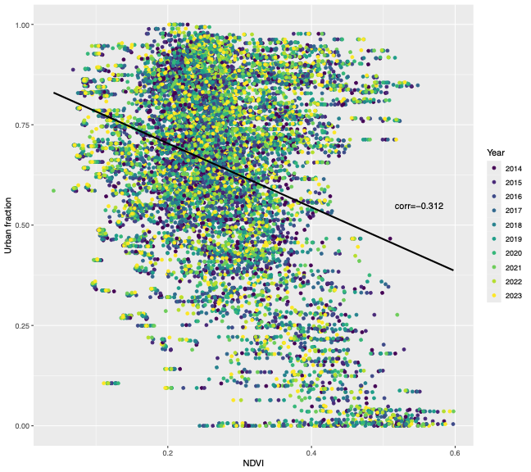

Figure S8. Association between NDVI and urban fraction by city and year. Each dot represents a city for a particular year, indicated by color.
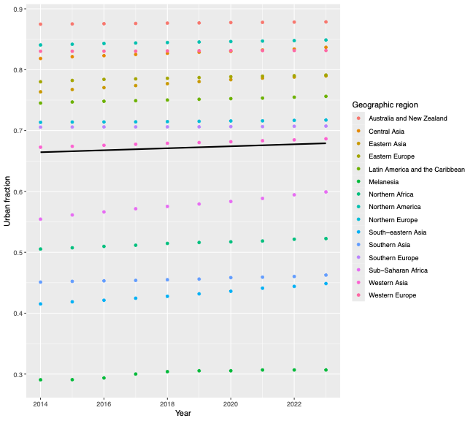

Figure S9. Association between urban fraction and year. Each dot represents the average urban fraction for a particular geographic region, indicated by color.

M. Friedl, D. Sulla-Menashe. 2022. MCD12Q1 MODIS/Terra+Aqua Land Cover Type Yearly L3 Global 500m SIN Grid V061. NASA EOSDIS Land Processes DAAC. https://doi.org/10.5067/MODIS/MCD12Q1.061

